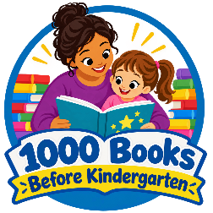
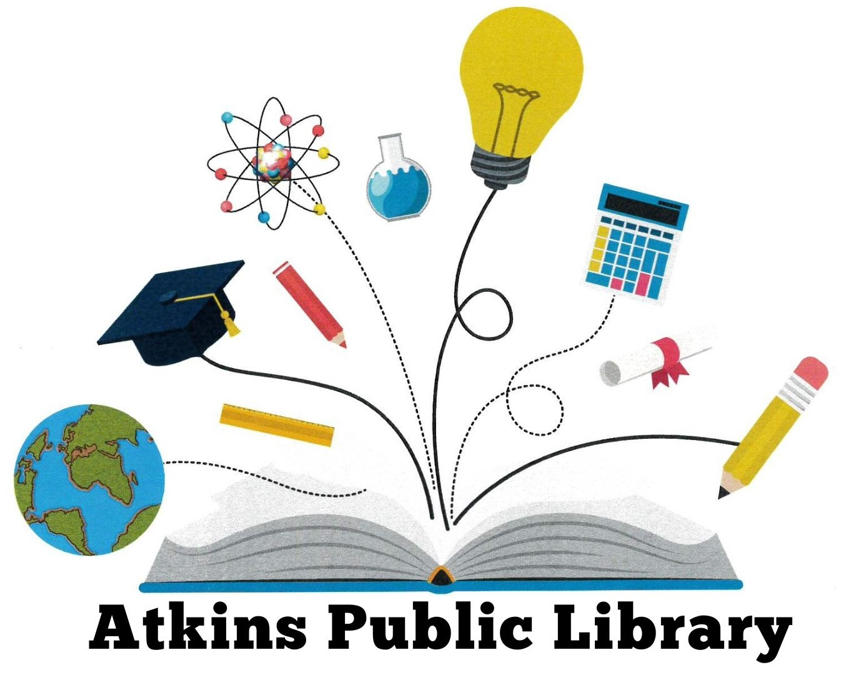

1000 Books Before Kindergarten
Reading Log

Child’s Name: ____________________________ Child’s Age: __________

1 |  | 26
2 |  | 27
3 |  | 28
4 |  | 29
5 |  | 30
6 |  | 31
7 |  | 32
8 |  | 33
9 |  | 34
10 |  | 35
11 |  | 36
12 |  | 37
13 |  | 38
14 |  | 39
15 |  | 40
16 |  | 41
17 |  | 42
18 |  | 43
19 |  | 44
20 |  | 45
21 |  | 46
22 |  | 47
23 |  | 48
24 |  | 49
25 |  | 50

51 |  | 76
52 |  | 77
53 |  | 78
54 |  | 79
55 |  | 80
56 |  | 81
57 |  | 82
58 |  | 83
59 |  | 84
60 |  | 85
61 |  | 86
62 |  | 87
63 |  | 88
64 |  | 89
65 |  | 90
66 |  | 91
67 |  | 92
68 |  | 93
69 |  | 94
70 |  | 95
71 |  | 96
72 |  | 97
73 |  | 98
74 |  | 99
75 |  | 100

Please indicate one:

1-100

101-200

201-300

301-400

401-500

501-600

601-700

701-800

801-900

901-1000

Pick up a prize at the Atkins Public Library after each 100 books read. After 1000 books, you’ll earn a completion prize and a certificate.

