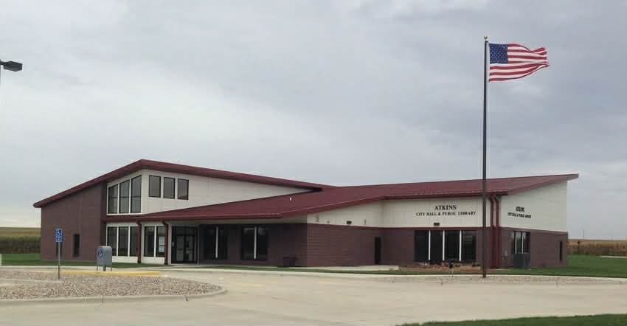
2026-2031 Atkins Public Library
Strategic Plan
Our Mission: We strive to provide a welcoming place for the community to come together to grow and connect with others in the community.
Our Vision: We are committed to enriching lives through access to programs and collections that encourage lifelong learning and the love of reading. We are dedicated to exceptional customer service and engaging our community.

Adopted by the Atkins Public Library of Trustees February 2nd, 2027.
This plan was developed in accordance with the State Library of Iowa Standards of Accreditation. Our mission, vision, goals, and objectives were developed through data obtained through community members and community businesses, and through input from our Library Director, staff and patrons.

Circulation and Patron Engagement:
Ensure the library’s active involvement in the community through strategic programming and dynamic reading initiatives, with a goal of raising circulation statistics and fostering a culture of learning for all ages.
- Objective 1. Our Library Director will report circulation statistics and trends to the Library Board monthly.
- Objective 2. We will offer a minimum of 4 programs for ages 0-5 per month.
- Objective 3. We will offer a minimum of 4 programs for ages 6-11 per month.
- Objective 4. We will offer a minimum of 1 program for ages 12-18 per month.
- Objective 5. We will offer a minimum of 1 evening program for adults per month.
- Objective 6. We will host a summer reading program.
- Objective 7. We will connect with a local daycare provider and hold 2 reading programs at their establishment per month.
- Objective 8. We will connect with local schools and introduce our library in a school setting once a month.
Community Outreach Goal:
Establish meaningful connections with community-based organizations, schools, and individuals, foster awareness, satisfaction, and support for library services through strategic outreach, events, and communication.
- Objective 1. We will maintain relationships with at least 4 community-based organizations, including schools, that provide services for both youth and adults.
- Objective 2. We will attend a minimum of 2 community events during the year to promote library services and community outreach.
- Objective 3. We will maintain providing timely information on library websites and social media accounts.
- Objective 4. Fosters community partnerships for library programs and services.
Facilities and Collection Goal:
Ensuring that the facilities and services are accessible, optimizing our collection, and maintaining accreditation standards. We will maintain a high-quality building, thereby creating a welcoming and well-managed environment for the community.
- Objective 1. We will ensure that the facilities and services remain accessible to all users.
- Objective 2. We will maintain reliable public internet access, Wi-Fi, and computers, offering basic technology assistance to patrons.
- Objective 3. We will perform an annual inventory of our full collection.
- Objective 4. We will maintain Tier 3 accreditation.

Staff and Volunteers Goal:
Foster a thriving and empowered library team by establishing and maintaining staff endorsements and continuing education requirements, prioritizing staff development, and building a robust network of volunteers to enhance library operations and community engagement.
- Objective 1. We will establish and maintain staff endorsements and continuing education requirements as appropriate to each position.
- Objective 2. We will establish and maintain a network of volunteers to assist in the operations of the library.
- We will maintain a budget line item for staff development.

